Purpose: Renew Lapsed Gator Too Members Audience: Lapsed Gator Too Members

Appeal Code: MEMA5 Timing: 30 Days after First Email

Subject: It’s Not Too Late!

Pre-Header: We’re sorry to see you go!

<First Name>,

We noticed that your Gator Too Membership with the UF Alumni Association lapsed.

If you would like to remain a UFAA member, you can still renew or upgrade online today! https://www.ufalumni.ufl.edu/join/default.aspx?ac=MRAI All members who renew with this link will receive an exclusive UFAA wall calendar!

Wall calendar image here
Renew

https://www.ufalumni.ufl.edu/join/default.aspx?ac=MEMA5#Text

If you do not want to renew, please take a moment to answer our short survey and let us know what we can do to improve your experience with the UFAA.

Exit Survey

https://ufl.qualtrics.com/jfe/form/SV_ezEbefDUZPcBqex

Thank you very much for taking the time to help us improve the membership experience.

Go Gators!

Eric Martin
Assistant Director of Membership & Philanthropy
UF Alumni Association

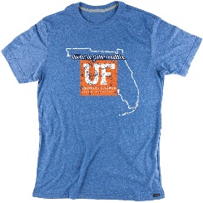
Interested in an exlcusive Rooted in Gator Tradition T-Shirt?
Simply sign up as a Recuring Annual Member to become eligible.
Once your membership is processed, we will send you redemption instructions via email for your T-Shirt.

RENEW TODAY!

