UFAA Virtual Gator Run 10K & Half Marathon – Runner Thank You
Audience: Registered Virtual 10K & Half Marathon Participants Date: 2/2/2018
Subject: [First Name], Thank You for Participating Pre-Header: Virtual Gator Run 2017
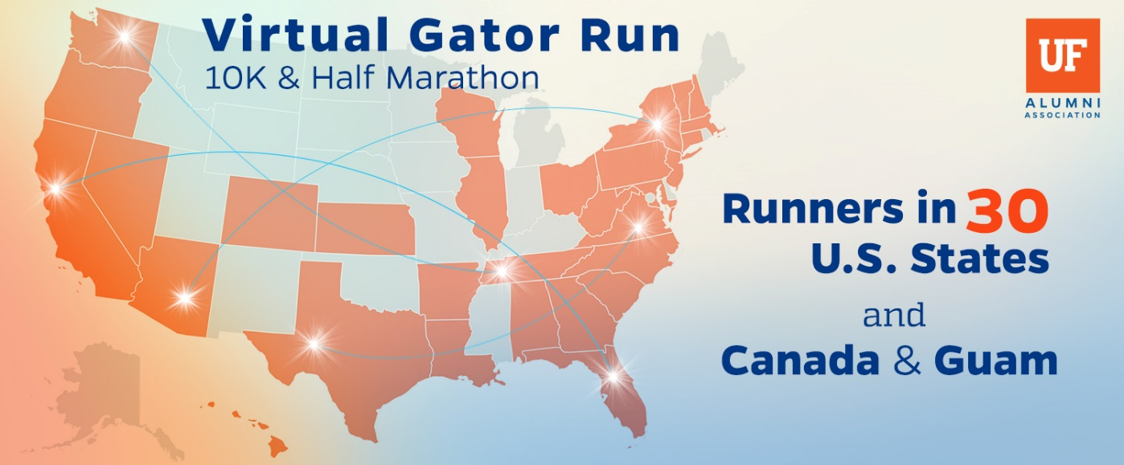

%%First Name%%, thank you for participating in the 2nd Annual Virtual Gator Run 10K & Half Marathon.
Next year we want to make this event more impactful and span the globe, but we need your help. Please take a few moments to answer a brief survey about what you liked and what we can do better.
SURVEYhttps://ufl.qualtrics.com/SE/?SID=SV_73c2xLVToooj1xr
With participants in 30 states and 2 countries, your participation supported the Florida Cicerone programming, helping to host over 50,000 University of Florida guests annually. Thank you!

Go Gators!

Eric Martin
The UF Alumni Association

P.S. Do you have a picture of your T-Shirt and medal from the event? Send them to ufalum@ufalumni.ufl.edu and your photos could be featured on FaceBook page!

