Join us for the Edward D. Stone, Jr. Lecture Series
In remembrance of Edward D. Stone, Jr., a beloved colleague, mentor, partner, advisor and friend, the University of Florida's Department of Landscape Architecture will host this lecture in his honor, commemorating Stone's numerous contributions to the fields of landscape architecture and land planning.
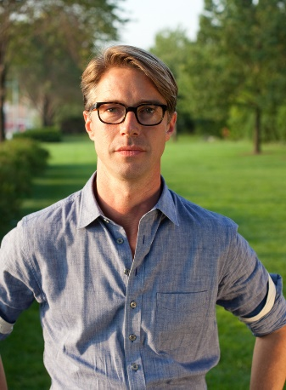

Time, Place and Story: Design at the Crossroads of Ecological and Cultural Systems by Thomas Woltz
Friday, February 23
6:00 to 7:30 p.m.
Harn Museum of Art
University of Florida

About the lecture
In his lecture, Woltz will draw from recent Nelson Byrd Woltz Landscape Architecture projects to illustrate the firm’s design process that begins with ecological and cultural research. Teamed with conservation biologists, NBW embeds the design team on sites for extended research and monitoring while engaging in parallel historical research. The first design responses are inspired by this research and collaborative approach, resulting in design responses inspired by the past while building resilient systems for the future. Each project seeks to attain design excellence in the stewardship of ecology, place and history.
About the presenter
Over the past two decades of practice, Thomas Woltz has forged a body of work that integrates the beauty and function of built forms with an understanding of complex biological systems and restoration ecology. NBW projects create models of biodiversity and sustainable agriculture within areas of damaged ecological infrastructure and working farmland, yielding hundreds of acres of reconstructed wetlands, reforested land, native meadows and flourishing wildlife habitat.
At present, NBW is entrusted with the design of nine major public parks across the United States, Canada and New Zealand. In addition to the Aga Khan Garden, Alberta, Canada, these projects include Hudson Yards in New York City, Memorial Park in Houston, and Centennial Park in Nashville.
In 2011, Thomas was invested into the American Society of Landscape Architects Council of Fellows, among the highest honors in his profession, and in 2013 he was named Design Innovator of the Year by the Wall Street Journal magazine.
Click here for more information.
Questions or for hotel information, Please email Melissa Martin

