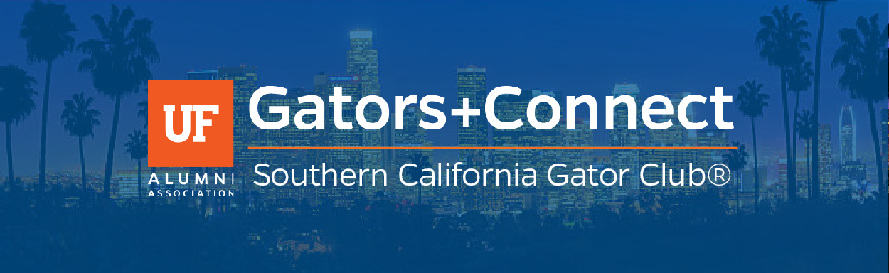
The University of Florida Alumni Association presents:

Gators+Connect

Hosted by:
Southern California Gator Club®

Wednesday, February 7, 2018
6:30pm - 8:30pm
Angel City Brewery
216 Alameda St
Los Angeles, CA 90012

Join the SoCal Gator Club® and the UFAA to meet and network with fellow Gators.
The SoCal Gator Club® is excited to welcome Mariah Curry, Scott Francis, and Executive Director Matt Hodge from the UF Alumni Association to share exciting things that are on the horizon for the University of Florida and the UF Alumni Association. You don't want to miss this Orange and Blue evening!
Admission is Free
Those who RSVP will receive a complimentary drink ticket, and UFAA members who will receive 2 complimentary drink tickets.

Count me in!

Register online by clicking the button above, or contact the UF Alumni Association at 352-392-1905 or slynn@ufalumni.ufl.edu

