YOU’RE INVITED
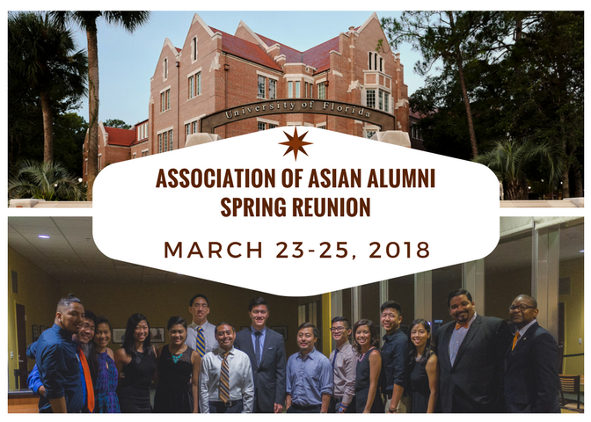
Join the
UF Association of Asian Alumni
and the
UF Alumni Association
for the
3RD Annual Asian Alumni Spring Reunion
March 23 - 25, 2018
Connect with students who are active in the Asian American community at UF,
and engage with fellow alumni at this exciting weekend in Gainesville.
REGISTER TODAY!

For more information visit www.aaaufalumni.com.

