**Page Title: Grateful Gator Day 2018**

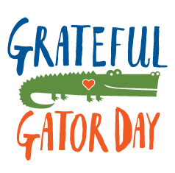

**What is Grateful Gator Day?**

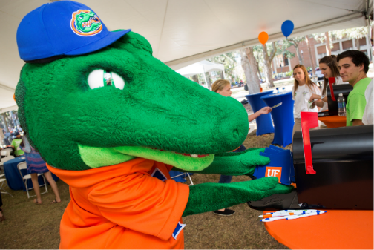Grateful Gator Day is an annual event celebrating the philanthropic generosity of University of Florida donors by providing an opportunity for UF students to personally thank donors through multiple communication platforms.

As a campus partner, you understand the transformative impact of philanthropy! Mark your calendar for Grateful Gator Day and help say thank you to the more than 99,000 donors who support UF last year.

**When is Grateful Gator Day?**

**Wednesday, March 14, 2018**

**9:00 am to 1:00 pm**

**Plaza of the Americas**

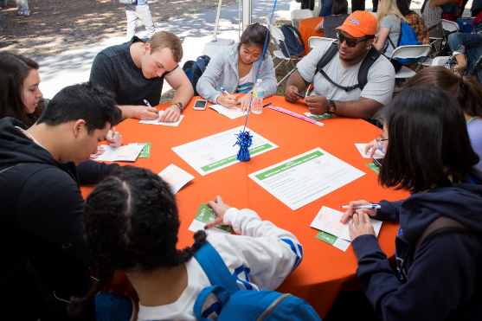**** 

**How can my college or unit get involved?**

With more than 99,000 people to thank for their support over the past year, we need your help spreading the message about the event among the student body and thanking donors. Here are some ways you can join in the effort:

* Encourage students to **attend the celebration** at the Plaza of the Americas on March 14 by sending emails, posting flyers and posting on social media.
* **Get Social!** Share information about Grateful Gator Day on your college or units social media pages and also use the opportunity to educate on why philanthropy is important.
* **Host an event** in your building for students who can’t make it to the Plaza. Events can be the same day or leading up to Grateful Gator Day. Share information about Grateful Gator Day and the importance of philanthropy, and have students write thank you cards with personal messages to send to your donors.
* **Create a photo booth** with fun university or C/U props. Have students hold signs like “I’m a Grateful Gator” or “Saying Thank You is what Grateful Gators Do.” Offer to take pictures with students’ phones so they can share on social media.
* **Send a thank you message to your donors**. Involve your faculty, staff, interns, and even your Leadership in gratitude activity - it can be an email from the Dean, phone calls from team members, or get creative and make a video to share.
* Add a **personal** touch by calling donors and saying thank you.

We have created a toolkit to guide you in highlighting the importance and impact of private support in your college. Use this toolkit and take to social media with the #GratefulGator Nation.

**Link to Grateful Gator Day C/U Toolkit**

Donor Relations will provide lists of recommended donors for each college and unit to reach out to on Grateful Gator Day.

**Grateful Gator Day Toolbox**

**(Provide Wordmark_3COLOR_STACK, Toolkit, A Couple of the GGD Screen Messaging/Promo Samples, Social Images – Facebook, Twitter and Instagram) – Use box link to access**

**For questions or more information, contact:**

Claire Burns

Associate Director of Donor Programs

(352) 392-7762

[cburns@uff.ufl.edu](mailto:cburns@uff.ufl.edu)