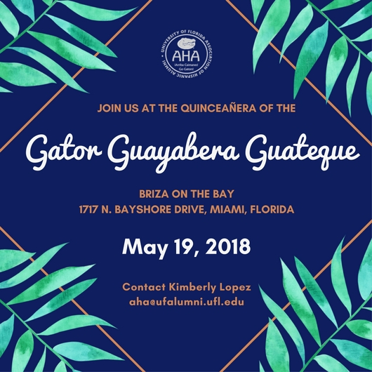

2018 GATOR GUAYABERA GUATEQUE

The Gator Guayabera Guateque (GGG) was started in 2004 by the University of Florida Association of Hispanic Alumni (UF-AHA) and is the organization’s signature event. The annual gathering of hundreds of Gator alumni and friends is designed to celebrate UF’s rich Hispanic culture and raise funds for student scholarships, including the UF-AHA academic endowment.

The 2018 Gator Guayabera Guateque is the 15th Annual Gator Guayabera Guateque for the UF AHA. We're celebrating the Gator Guayabera Guateque’s Quinceañera!

May 19, 2018
Briza on the Bay
1717 N. Bayshore Drive, Miami, Florida

Tickets: Click here to purchase tickets. (https://secure.1stpaygateway.net/secure/custompayment/universityoffloridaassoci/5517/default.aspx)
Sponsorship Options: Click here for sponsorship opportunities. (https://drive.google.com/file/d/0B92P4fivdIQYeWdpZ0hRSG1WWWhhRE1Bb3pwZU1SU2lQNzFn/view)

For additional questions, contact Kimberly Lopez at aha@ufalumni.ufl.edu.

