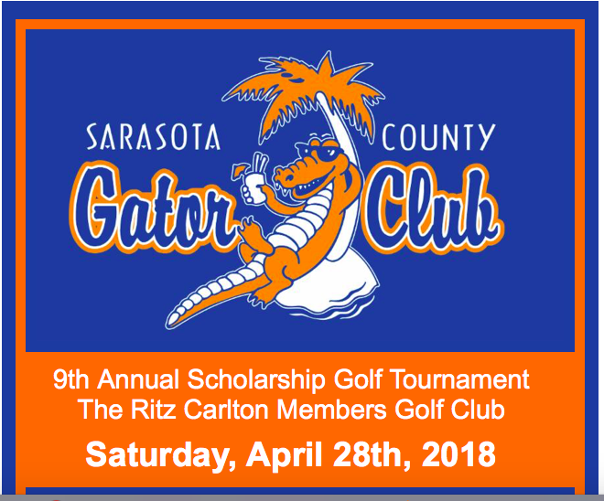

A great day of golf and an opportunity to support the Sarasota County Gator Club's Scholarship Program! Join a team, host a team, or come hang out with Gator fans and former Gator football players. There will be food, drinks, silent auction and give-aways!

REGISTER TODAY!

1 PM Shotgun
Two Best of Four Format
$150 UF Alumni Association Members
$200 Non- UF Alumni Association Members
First & Second Place Gross & Net Winners will be Awarded
Hole in One Prizes on All Par 3's & On-Course Prizes

Sponsorship opportunities include golf tournament sign sponsorship and scholarship
naming opportunities. For more information, please contact via email
at scgccommunications@gmail.com.
For more information visit www.sarasotagators.com/golf-tournament.html.
Course Questions? Contact The Ritz Carlton Pro Shop at 941-309-2900.

Stay connected with us for golf tournament and club updates!
 |  |  | 

Register Today Link:
http://www.sarasotagators.com/golf-tournament.html

Social Links:
Facebook: https://www.facebook.com/SarasotaGatorClub/?ref=bookmarks
Twitter: https://twitter.com/SRQGatorClub (@SRQGatorClub)
Instagram: https://www.instagram.com/sarasotaufaa/ (@sarasotaufaa)
LinkedIn: https://www.linkedin.com/in/sarasotagatorclub/

