Appeal Code: Requested on 02/12/2018 Timing: -30 Day Notice

Subject: The Clock is Ticking… Pre-Header: Renew Your Membership Today!

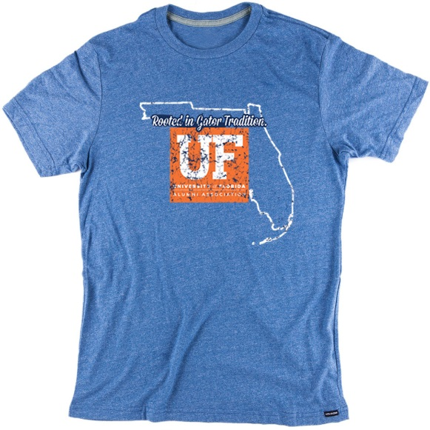
Dear <First Name>,

Your membership expired on <expiration date.> In order to retain your member perks like access to The Gator Nation® app and over 80 Gator Clubs®, renew today!

Renew Today

By clicking the link above and renewing for $25, you will receive redemption instructions for the Rooted in Gator Tradition T-Shirt, reserved for UFAA members!

Go Gators

The UF Alumni Association

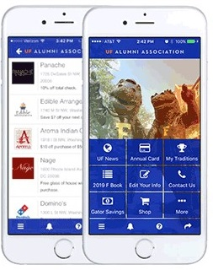
The Gator Nation® App

Activate your membership for another year and we’ll make sure you can access your digital perks. You’ll once again have access to your digital membership card, hundreds of discounts based on your zip code and the ability to connect with Gator Clubs® across the country!

