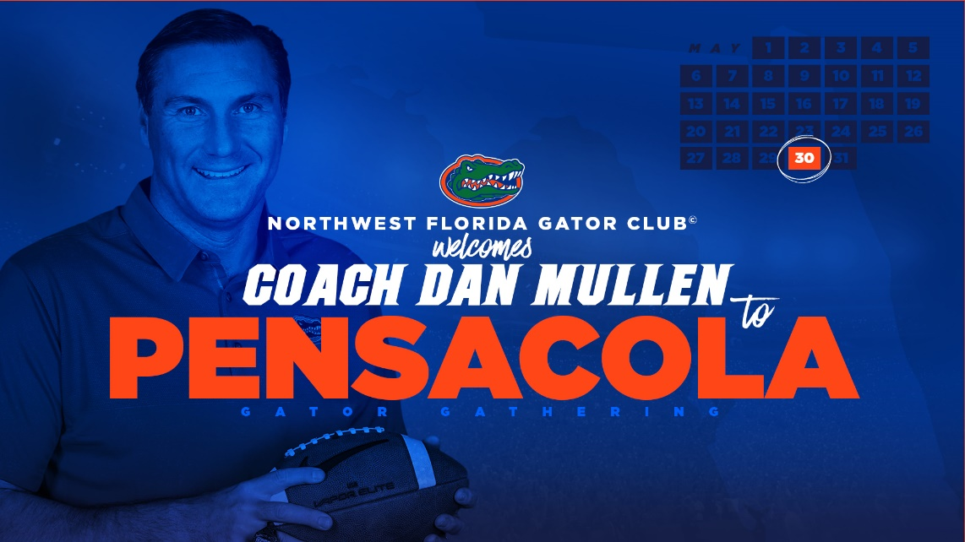
You're Invited! Help Welcome Coach Dan Mullen on May 30th!

Join the NW Florida Gator Club®, the UFAA, and
Gator Boosters to welcome Dan Mullen as the
27th Head Coach of Florida Football.
Event Details:
Wednesday May 30th, 2018
5:30pm // Doors Open
6:30pm// Program Begins
Refreshments will be available.

Sanders Beach Community Center
913 S I St,
Pensacola, FL 32502

Please RSVP by clicking the orange button below.
RSVP deadline is May 23, 2018.
RSVP NOW
We look forward to seeing you May 30 for this special opportunity with Coach Mullen.
University of Florida Alumni Association
1938 W University Ave | Gainesville, FL 32603

With support from our partners:
Contact Staci Mcdonough (SMcdonough@ufalumni.ufl.edu) for Corporate Membership and UFAA program sponsorship opportunities.
READ THIS EMAIL ONLINE
Stay Connected:
Download The Gator Nation® app
This message has been sent by the University of Florida Alumni Association to:
cbarnett@uff.ufl.edu
Unsubscribe/Manage Subscriptions
Manage Your Profile
The University of Florida Alumni Association solicits tax deductible private contributions for the benefit of the University of Florida. For our full disclosure statement, please visit our web site.

