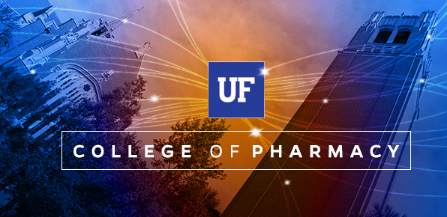

2018 UF College of Pharmacy Fall Gator Receptions

**AAPS Gator Reception**

Monday, November 5, 2018

5:30pm – 7:00pm

Marriott Marquis

901 Massachusetts Ave, NW

Washington, DC 20001

Link: <https://pharmacy.ufl.edu/event/aaps-uf-college-of-pharmacy-gator-reception/>

**ASHP Gator Reception**

Sunday, December 2, 2018

5:30pm – 7:00pm

Marriott Anaheim

700 West Convention Way

Anaheim, CA 92802

Link: <https://pharmacy.ufl.edu/event/ashp-uf-college-of-pharmacy-gator-reception/>

Questions? Please contact College of Pharmacy Events Office

[events@cop.ufl.edu](mailto:events@cop.ufl.edu) or 352-294-8265