Purpose: Renew New Grad Members Audience: Expiring New Grad Members
Appeal Code: MN014 Timing: +60 Day Notice
Subject: ACTIVATE TODAY: Your Membership Expires Soon Pre-Header: The UF Alumni Association

Dear <First Name>,
Can you believe a year has passed since you received a gifted UFAA New Grad membership?
Time is flying by so do not forget to claim your second year of membership that we, your hometown Gator Club® purchased for you.
Please click below to activate your gifted membership for another year!
<First name here>, Activate Your Gifted Membership

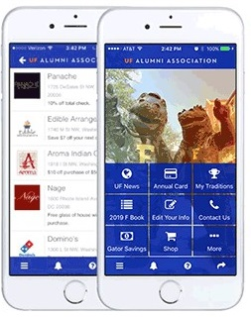
Did you know your membership is 100% digital?
Download The Gator Nation® app today! Log in with <email address> and your last name, <insert last name>, to access your digital membership card, hundreds of discounts based on your zip code and to participate in events like the Virtual Gator Run 10K!
Go Gators!
The UF Alumni Association

