Appeal Code: MN016 Timing: +15 Day Notice
Subject: Two Weeks Left! Pre-Header: Activate Your Membership Today!

Dear <First Name>,
Your membership expires in two weeks!
Once again, your local Gator Club® has gifted you a second year of UFAA membership. There is no cost to you!
<First name here>, Activate Your Gifted Membership

Renew today and be eligible to participate in the “Cracking the New Job Market” online webinar presented by William Howard. Mr. Howard is an award-winning college professor, business executive, and author of four books on career management.
You will learn how to:
- Gather information on what a prospective employer finds important.
- Emphasize those skills, accomplishments, and qualities in tailored resumes and interview answers.
- Identify the intersection between personal talents and what the marketplace needs.

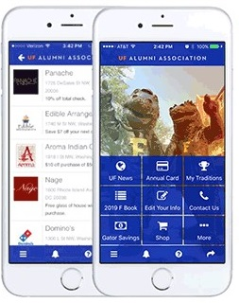
Looking for your membership card?

Download The Gator Nation® app today! Log in with <email address> and your last name, <insert last name>, to access your digital membership card, hundreds of discounts based on your zip code and to participate in events like the Virtual Gator Run 10K!

Go Gators!

The UF Alumni Association

