Appeal Code: MN019 Timing: -30 Day Notice

Subject: FINAL NOTICE: UFAA Membership Pre-Header: Renew Your Membership Today!

Dear <First Name>,

Your membership is expired. This is your final notice and the final opportunity to activate your GIFTED membership courtesy of your local Gator Club® This is a $25 value! All you need to do is update your contact information and you’ll be a member for one year!

<First name here>, Activate Your Gifted Membership

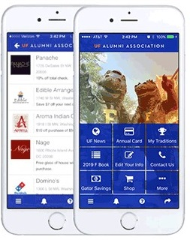
The Gator Nation® App

Activate your membership for another year and we’ll make sure you can access your digital perks. You’ll once again have access to your digital membership card, hundreds of discounts based on your zip code and the ability to connect with Gator Clubs® across the country!

Go Gators!

The UF Alumni Association

