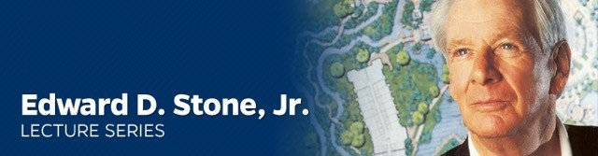

**Join us for the Edward D. Stone, Jr. Lecture Series**

In remembrance of Edward D. Stone, Jr., a beloved colleague, mentor, partner, advisor and friend, the University of Florida’s Department of Landscape Architecture will host this lecture in his honor, commemorating Stone’s numerous contributions to the

fields of landscape architecture and land planning.

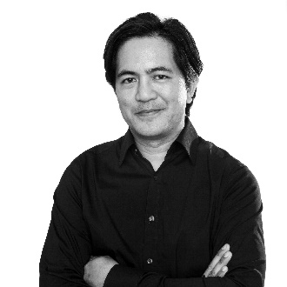

**Infrastructural Futures**

**Presented by Gerdo Aquino**

**Firmwide CEO for SWA**

Friday, March 31

7:00 to 8:30 p.m.

[Harn Museum of Art](https://www.google.com/maps/place/Harn+Museum+of+Art/@29.6370469,-82.3702048,17z/data=!4m2!3m1!1s0x88e8a33f0e1a5b57:0x6cca8184b14e330b)

University of Florida

**About the lecture**

Cities are urbanizing at an accelerated rate in part, due to advanced mobility strategies, vertical development, civic/cultural programming and jobs. It is estimated that by 2050, 75% of the world’s population will be living in cities. This increase in density, coupled with climate change, will place a continued strain on critical resources and the infrastructure needed to support growth. Mr. Aquino will present an approach that argues for the creation of a multi-functional public realm where great design, ecology and infrastructure are re-imagined into robust systems that will move our cities aggressively into the next century.

**About the presenter**

UF Landscape Architecture Alumnus Gerdo Aquino is firm-wide CEO of SWA based in Los Angeles, an award-winning global practice operating on the leading edge of landscap¬¬e architecture, urban design and planning. With 20 years of professional experience, he has had much success in solving a wide range of environmental landscape design problems for projects where open space, density, and place-making are key issues, and he has gained a thorough understanding of the public review process, which often includes extensive cultural, historical, public art, and public participation components. Gerdo’s notable public realm projects include the redesign of the culturally significant San Jacinto Plaza in El Paso, and the design of Belgrade Serbia’s Sava Promenada, a 1 kilometer urban waterfront that will reconnect the city’s historic center to the Sava River.

Gerdo is also adjunct associate professor at the University of Southern California and has taught option studio at the Harvard Graduate School of Design over the past two years. He has served on the Harvard Design Magazine editorial board, USC academic advisory committee, has lectured at important institutions in around the world and co-authored the award-winning research publication- Landscape Infrastructure: case studies by SWA (Birkhauser, 2013-14 first, second edition) that examined the future role of infrastructure in balancing ecological systems, economic development and open space needs within dense urban cities.

For more information:

<https://dcp.ufl.edu/landscape/lecture-series/>

Questions or for hotel information,

please email [Melissa Martin](mailto:melissasmartin54@dcp.ufl.edu)