Greetings “insert last name” Family!

We hope you are as excited as we are to be involved and connected parents! There are many ways in which UF parents may engage with the university. Here are two that we hope may be of interest to you:
UF Parent and Family Philanthropy Council members are parents and family members of current and incoming students who serve as ambassadors for the Gator Nation. We provide input and feedback on important issues and trends impacting the university and higher education, and advocate and assist with our Gator’s college as well as university-wide programs. Our members attend two meetings per year, make an annual gift of $5,000 to any area at the University of Florida and consider a major gift commensurate with their financial means to any UF college, program or initiative.
UF Parent and Family Leadership Society recognizes those who help to propel the university to new standards of excellence by making charitable contributions and are acknowledged based on their giving level. Benefits include opportunities to engage with university leadership, invitations to exclusive events and access to special seating at Commencement.
Once again, welcome to the Gator family! For further information on parent & family giving and engagement opportunities, please contact Carl Archut Jr. at carchut@uff.ufl.edu or (o) 352-392-5471.

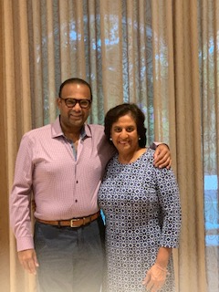
Go Gators!

Nisha Bhardwaj & Suresh Raja PA’22
Incoming Co-Chairs, UF Parent & Family Philanthropy Council

