**Photos:** <https://drive.google.com/drive/folders/1VuoJxJ408NhEFvU8DAthvIlP_i8rLSEk?usp=sharing>

**Officers Page:** Update to below headshots, contact information in this order

Meet Our Executive Board

**Bianca Jean Philippe**

She/Her

President

Contact: [flcicerones@gmail.com](mailto:flcicerones@gmail.com)

**Abel Abraham**

He/Him

Executive Vice President

Contact: [fcexecutivevp@gmail.com](mailto:fcexecutivevp@gmail.com)

**Janae K Hodge**

She/Her

Programming Vice President

Contact: [fcprogrammingvp@gmail.com](mailto:fcprogrammingvp@gmail.com)

**Sarik Shah**

He/Him

Membership Vice President

Contact: [fcmembershipvp@gmail.com](mailto:fcmembershipvp@gmail.com)

**Ava Madara**

She/Her

Students Today, Alumni Tomorrow Vice President

Contact: [fcstatvp@gmail.com](mailto:fcstatvp@gmail.com)

**JP Ricardo**

He/Him

Internal Vice President

Contact: [fcinternalvp@gmail.com](mailto:fcinternalvp@gmail.com)

**Halima Attah**

She/Her

Communications Vice President

Contact: [fccommunicationsvp@gmail.com](mailto:fccommunicationsvp@gmail.com)

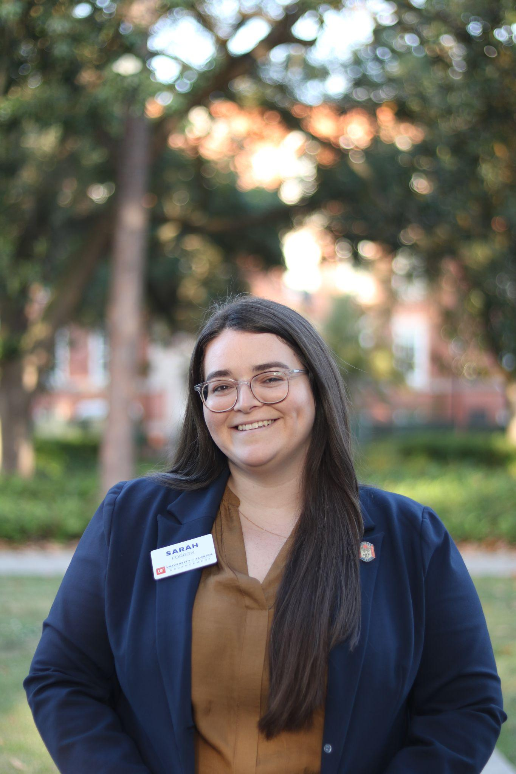

**Sarah Forron**

She/Her

Assistant Director for Young Alumni Programs and Advisor to the Florida Cicerones

Contact: [sarahcforron@ufl.edu](mailto:sarahcforron@ufl.edu)