**CALLING ALL GATORS!**

Come join the Pinellas County Gator Club at our 2025 Official Football Watch Party location, **Mutts and Martinis on Central in St. Petersburg**! We will be playing every Gator football game on 28 big screen TVs with 3 surround sound systems all throughout the indoor and outdoor space. Mutts and Martinis is providing Gator fans with a delicious game day food and drink menu, including specials specifically for PCGC and watch party attendees. We are family and pet friendly, all for the Gators stand up and holler!

Mutts and Martinis does have a separate doggie play area and bar, so if you would like to bring your dog, please head to their website to pre-register your dog for quicker entry.

[www.muttsandmartinisoncentral.com](http://www.muttsandmartinisoncentral.com)

Dogs are welcome, but not required. If you are attending without a dog, just head past the check-in desk and out to our gated, covered, turf area reserved for the Pinellas County Gator Club and fans!

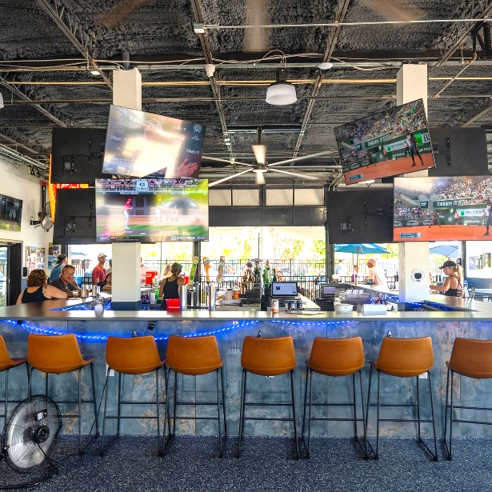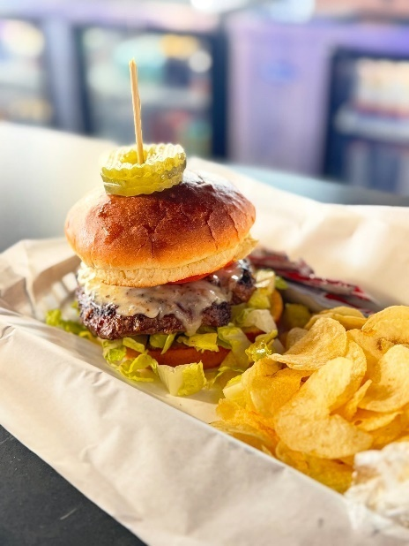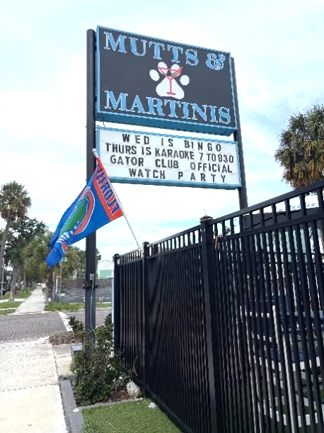

We hope to see you there and Go Gators! If you have any additional questions about our watch parties, please email [pcgatorclub@gmail.com](mailto:pcgatorclub@gmail.com) or send a message to our socials @pinellascountygatorclub. You can also visit us at [www.pinellascountygatorclub.org](http://www.pinellascountygatorclub.org) to subscribe to our listserv and stay up to date on other events.

**Mutts and Martinis**

**2900 Central Avenue**

**St. Petersburg, FL 33712**

Are you also a Tampa Bay Buccaneers football fan? Come join the Pinellas County Gator Club cheer on some former Gator greats at Raymond James when the Bucs play the New Orleans Saints on Sunday, December 7th at 1:00pm. Head to the link below to purchase tickets, 200 and 300 level available. A portion of ticket sales will go towards our Scholarship Fund!

[Get your Tickets Here!](https://www.gofevo.com/event/Pinellascounty65)