Email #5 – Stewardship
Drop Date: Sept 22 (or any time that week)
Subject Line: A special thank-you gift just for you
Preview Text: Your support makes a difference — enjoy these exclusive BEAT designs.
Signer: Yoon Van Hout

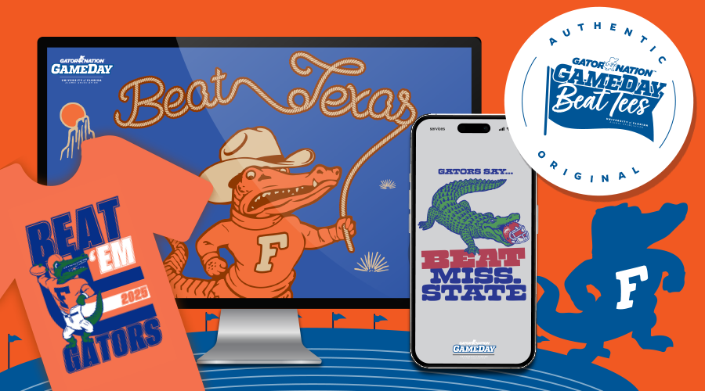
Hi {First Name,
Thank you for supporting the Gator Nation with the purchase of your annual BEAT Tees. Your gift not only helps fuel the UF programs and areas you care about most, but it also unites Gators everywhere in pride and tradition.
In appreciation of your support, we’ve created exclusive BEAT-inspired mobile and Zoom backgrounds for supporters like you. They’re the perfect way to show your Gator spirit on the go or online.
👉 [Download Your BEAT Designs]
Because of you, the Gator Nation grows stronger every season. Thank you for making a difference and showing what it means to be a Gator.
Go Gators!
Yoon Van Hout
Executive Director of Annual Giving and Donor Experience

