Halfway email from Student
Wednesday, Oct.1st
9am
From: Connor Harper
Subject: 5 days left to double your impact

Dear ____[First Name]
With just five days left in the 2025 Crisafi Challenge, we are pushing hard to raise $50,000 for recruitment scholarships. Your gift today will be matched dollar-for-dollar through a legacy gift established by Dr. Bob, meaning every gift will have DOUBLE the impact on students like me at the UF College of Pharmacy. Don’t miss this chance to make a difference!
From a young age, I was taught to dream big and push beyond what I thought was possible. My father set the example, working 70-hour weeks while slowly earning his bachelor’s degree, so his children could have greater opportunities. His perseverance inspires me daily as I work toward becoming a pharmacist. The Crisafi scholarship allows me to focus on my studies without the burden of overwhelming debt, while also showing me that the UF College of Pharmacy believes in my future. I am proud to represent the Crisafi Scholars and deeply appreciative of the donors who make my dream possible
By giving to the Crisafi Challenge this year, you can help us recruit top students to our college, where their impact will be felt for generations to come.

{Give today button}
Video Link - https://www.youtube.com/watch?v=VOhV9Kz5m8w

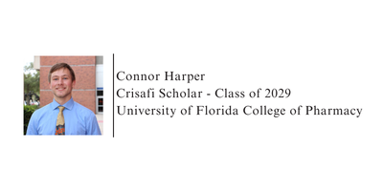
With gratitude,

