Looking for the perfect Gator gift this holiday season? We’ve got you covered.

UF Alumni Association Membership
- Supports Gator Clubs® and alumni programs
- Provides over $400,000 in scholarships every year
- If your UFAA membership lists a local NYC area address, you’re automatically a member of the Gotham Gator Club®
Gift a Membership

Gotham Gators Gear
- Choose from tees, tanks, long sleeves, and sweatshirts
- Support the Gotham Gators in all kinds of weather
- Proceeds go directly to our scholarship fund
Shop the Collection
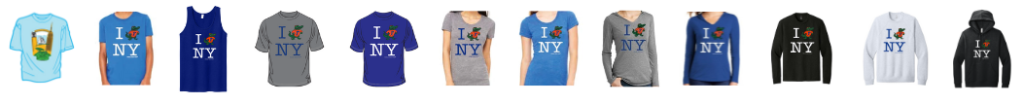

No matter which gift you choose, you will be supporting students, celebrating Gator traditions, and giving back to a community we all love. Thank you for being part of the Gotham Gators community. Wishing you a joyful holiday season full of Gator cheer!

Go Gators,
Liz Levine
President, Gotham Gator Club®

