Purpose: PCI Directory Expiring Members
Audience: Oct 31, 2017 Expiring PCI Annual Members
Appeal Code: MS083
Subject: T-SHIRT OFFER: Renew Your UFAA Membership
Pre-Header: Exclusive Rooted in Gator Tradition T-Shirt

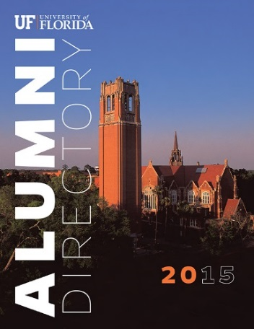
Dear [First Name],
Thank you for past purchase of the 2015 UF Alumni Directory and for being a UFAA Annual Member.
I hope you will continue to support the UFAA by renewing your membership as a Recurring Member, 3-Year Annual Member or consider upgrading to a Life Membership. https://www.ufalumni.ufl.edu/join/default.aspx?ac=MS083

<Yes, I want to Renew!>
https://www.ufalumni.ufl.edu/join/default.aspx?ac=MS083

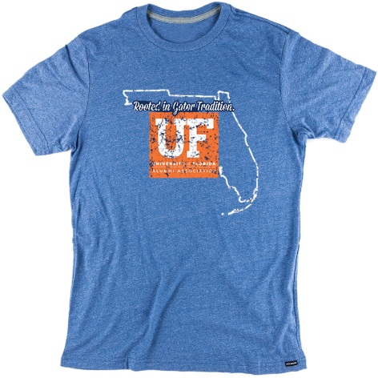

If you renew as a Recurring Member, 3-Year Annual or upgrade to a Life Membership you will receive this exclusive Rooted in Gator Tradition T-Shirt. Once your membership is processed you will receive an email with redemption instructions.

Thank you for you being a UFAA Member!

Go Gators!
Eric Martin
Assistant Director of Membership & Philanthropy

