Project: IRA Year-end Email
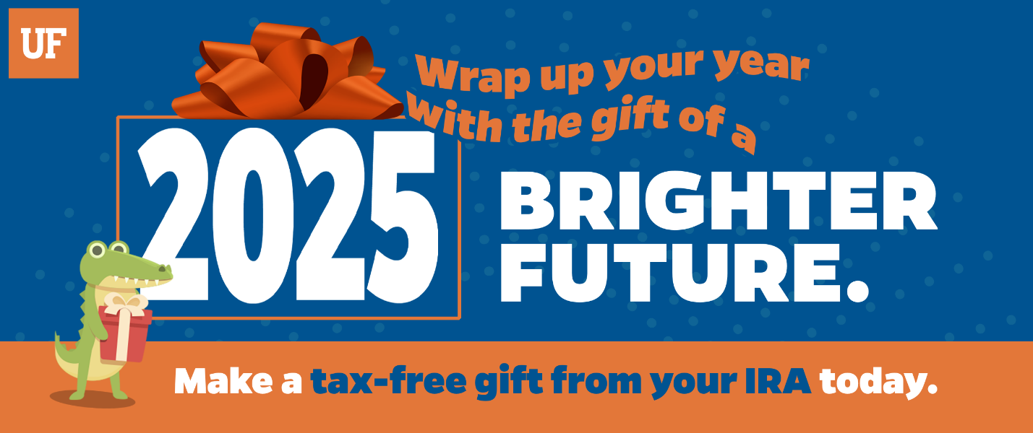
The University of Florida has a long history of helping people improve their lives. Through discovery and scholarship, and in partnership with generous supporters, UF has had a hand in shaping health care, space exploration, agriculture, education, business, engineering, conservation, the law and so much more. As one of the world’s most comprehensive universities, our university touches almost all aspects of the human condition and lights the way to a brighter future.
You can be part of that impact. By making a tax-free gift from your IRA, you can change lives and shape the future.
If you are 70½ or older, a Qualified Charitable Distribution (aka IRA charitable rollover) might be a great option for you. It’s an easy way to support the UF college, program or initiative that means the most to you.
BENEFITS:
- You will not have to include the distribution in your taxable income.
- Your gift may count toward satisfying your required minimum distribution (RMD) for the year.*
- You will experience the tax benefits of charitable giving even if you do not itemize your deductions. Learn more
DID YOU KNOW:
Another benefit of being 70½ or older is that you can fund a charitable gift annuity from your IRA.
Learn More
NEW QCD REPORTING CODE
Starting January 1, 2025, IRA custodians must use a new reporting code (“Code Y”) on Form 1099-R to identify QCDs. This change means your QCDs will be separately reported to the IRS, making it easier for you and your tax preparer to claim the benefit, while giving you added peace of mind that your charitable gift is properly recognized.
WE'RE HERE FOR YOU
UF's Office of Estate & Gift Planning can answer questions about IRA gifts.
giftplanning@uff.ufl.edu | 866-317-4143
Thank you and have a happy and safe holiday season!
*The Consolidated Appropriations Act of 2023 (Act) increased the age for required minimum distributions from retirement plans. The Act increased the age retirees must begin taking taxable withdrawals to age 73 in 2023 and age 75 by 2033, up from age 72 under the previous law. IRA owners can still make a qualified charitable distribution (QCD) starting at age 70½.

