Email version:

Subject Line: Honor Dr. Larry Edwards — Support UF Internal Medicine
Header: Dr. Larry Edwards shaped generations of physicians. Help us honor his legacy.
Body:

After more than two decades of leadership, Dr. Larry Edwards has retired as Residency Program Director for the UF Department of Medicine. Under his guidance, nearly 300 residents trained in a program that achieved a 100% board pass rate and a 98% fellowship match rate.
To celebrate his impact, several alumni have created the N. Lawrence Edwards, MD, Internal Medicine Resident Fund. This endowed fund supports:
• Fellowship preparation and research opportunities
• Integration of AI and new technologies
• Enhanced outpatient training
• Resident wellness initiatives

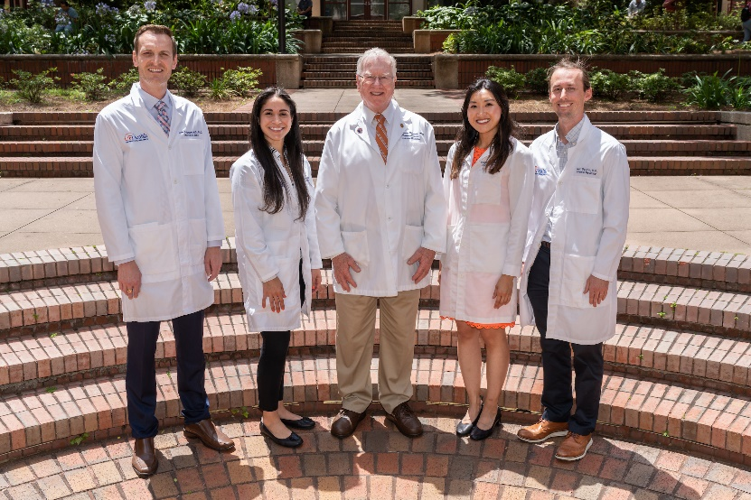

Make a gift now: [insert giving link]

Your gift will carry Dr. Edwards’ vision forward, ensuring UF continues to train exceptional clinicians dedicated to internal medicine.

With deep appreciation,


Jamie B. Conti M.D., FACC Jorge Lascano, M.D.
Professor and Chair, Department of Medicine Program Director, Internal Medicine
UF College of Medicine UF College of Medicine

