Subject Line: A Birthday Wish From Your Gator Family
Preview Text: Celebrating You Today

Happy Birthday!
Today, we’re celebrating you and the meaningful connection you share with the University of Florida. Gators like you help shape the spirit, strength, and future of this institution and we’re grateful for the role you play in our community.
Because of alumni and friends who care deeply about UF, students are discovering opportunities, pursuing bold ideas, and building foundations for lives of purpose and impact. Your pride in this university helps carry forward a legacy that has endured for generations.
We hope this year brings moments of joy, reflection, and celebration.
For Current Annual & Life Members:
Thank you for being a valued Life Member/ Annual Member of the Gator Nation—your membership helps strengthen the UF community and support students today and for generations to come.
For Non-Members:
If you’re looking for another way to stay connected to UF, we’d love to invite you to join the Gator Nation (Hyperlink) as a member and be part of supporting students and programs that make a lasting difference.
Warmest birthday wishes,
The Alumni Association
P.S. If you’re looking for a simple way to celebrate your birthday while showing your Gator pride, the Gator Specialty License Plate is one meaningful option. Every plate helps support UF students and programs, turning everyday miles into lasting impact.
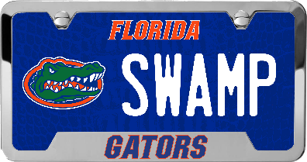
CTA: Claim your Gator Plate
or learn more here

