Purpose: Recruit Gators Run 305 Team Members
Audience: UFAA Members in Florida
Appeal Code: MR139
Subject: Run the 305 with fellow Gators!
Pre-Header: The UF Alumni Association is an official group partner of the Miami Marathon

Dear [First Name],
The UF Alumni Association is an official group partner of the Miami Marathon. UFAA Members can participate in the Miami Marathon as a part of the 2nd Annual Gators Run 305 Miami Marathon team!
REGISTER TODAY https://www.ufalumni.ufl.edu/rsvp/view/default.aspx?id=1296
Registration is a two-step process.
Step 1: Register for the Gators Run 305 Team by December 26, 2017.
- Information about $10 off your Miami Marathon registration will be included in your confirmation email.
Step 2: Register for either the Miami Full Marathon or Half-Marathon.
- Select the UFAA Group Affiliation, UF ALUMNI ASSOCIATION, from the drop down menu.
- Enter your unique discount code before you complete payment.

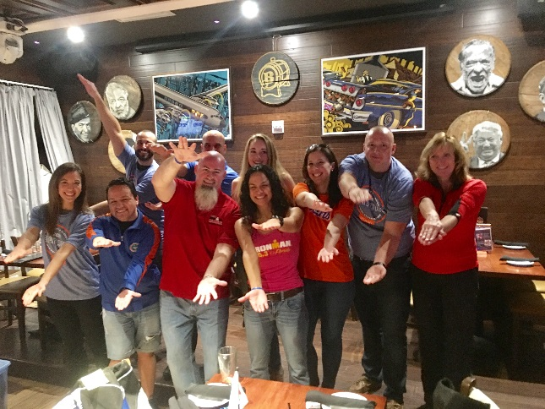
Gators Run 305 Team members receive the following:
- $10 discount on registration
- Gators Run 305 performance T-Shirt
- Gators Run 305 bag
- Gators Run 305 hat
- Invitation to the UFAA Pre-Party at Batch Gastropub on Saturday, January 27, 2018, including 15% off your food and drinks.
- Gator giveaways at our post-race tent in the Baptist Health Charity Village in Bayfront Park.
Pictured above: The 2017 Gators Run 305 Team at Batch Gastro Pub the night before the race.

Go Gators!
Eric Martin
Assistant Director of Membership & Philanthropy

