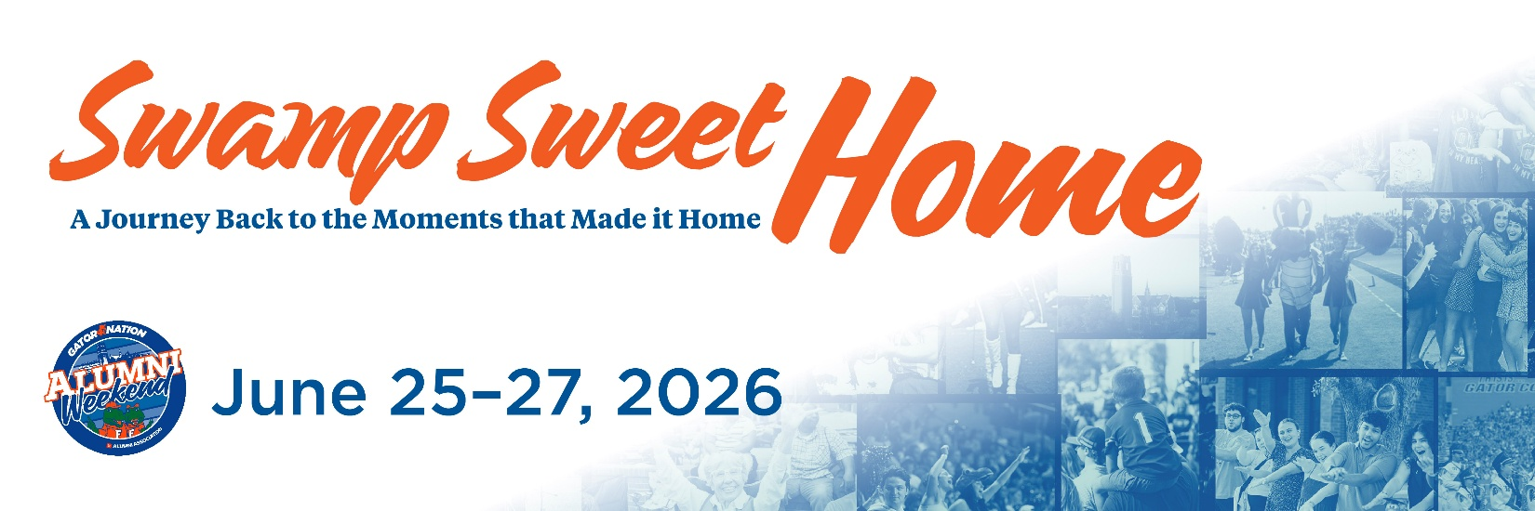

Grand Guard (1976) Email Invite 1
Subject: Fifty Years Later, the Moment Still Matters. You’re Invited to Grand Guard at Alumni Weekend 2026
Dear [FIRST NAME],
Fifty years ago, you began a journey that looked different for every person in your class. Different majors. Different friendships. Different paths forward. But something meaningful happened for you here.
There was a moment - maybe a decision, a connection, or a realization - that stayed with you long after you left campus. Over time, those moments became part of who you are and the life you have built.
This year, we invite you back not just to remember your time at the University of Florida, but to reflect on the moments that impacted your life and perhaps even future generations of your family. Alumni Weekend is a celebration of the experiences that shaped you, the friendships that carried you forward, and the shared history that continues to connect you.
"Swamp Sweet Home" is about honoring that journey, from then to now, and welcoming you back to the place where so much began. We invite you to explore the full schedule of events planned for the weekend—including your official Grand Guard induction ceremony—and register to join us for this historic milestone celebration June 25-27, 2026.
[Button: Register for Alumni Weekend 2026 {use this link https://cvent.me/wlEDOZ}]
Early Bird registration is now open, allowing you to secure your spot for the full weekend or individual events at our best available rate. We would be honored to celebrate this 50-year milestone with you and your fellow Grand Guard alumni.
With warm regards,
The University of Florida Alumni Association

