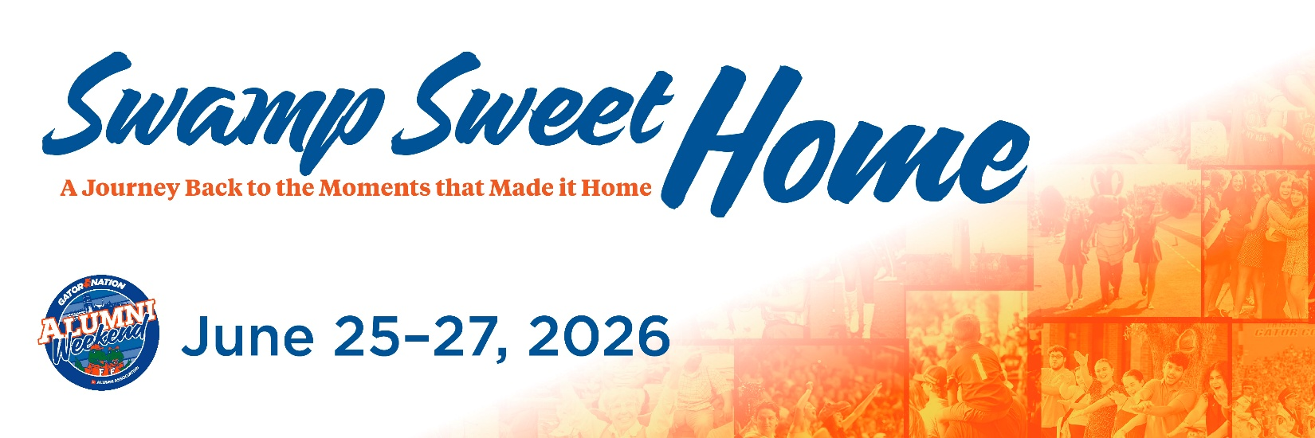

Milestone Classes Invite Email 1
Subject: Swamp Sweet Home: A Journey Back to the Moment that Made it Home. You’re Invited to Alumni Weekend 2026
Dear [FIRST NAME],
No matter what year you were here or how your experience looked, something meaningful happened for you at the University of Florida. A moment - big or small - helped shape who you are today.
This summer, we invite you back to reconnect with those moments during Alumni Weekend, a celebration designed to feel familiar, joyful, and personal. We call it Swamp Sweet Home - a journey back to the moments that made it feel like home.
Throughout the weekend, alumni from every generation and every path will come together to celebrate shared memories and reconnect with friends old and new. This cross-generational celebration offers a unique opportunity to engage with our storied traditions and Gators from many eras. You’ll be able to connect with the Gator Nation as we honor special milestones, including the Grand Guard induction of the 1976 50th reunion class and the 40 Gators Under 40 celebration, recognizing alumni whose impact is shaping the world today.
We also invite you to explore the full schedule and see first-hand how much UF has grown to create more meaningful moments for current students. Alumni Weekend isn’t about reliving the past — it’s about celebrating how far you’ve come and the progress that continues to define our university.
[Button: Register for Alumni Weekend 2026 {use this link: https://cvent.me/e0qkRb }]
Early Bird registration is now open, allowing you to secure your spot for the full weekend or individual events at our best available rate. Whether you return for one afternoon or the entire journey, we’d love to welcome you back home.
Warmly,
University of Florida Alumni Association

