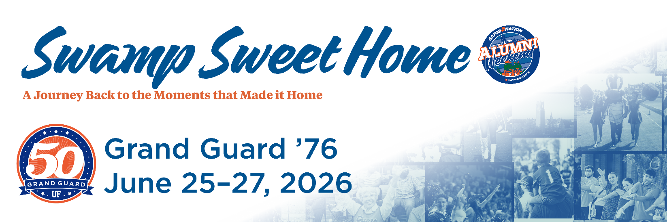

Grand Guard (1976) Email Invite 1
Subject: Fifty Years Later, the Moment Still Matters. You’re Invited to Grand Guard at Alumni Weekend 2026
Dear [FIRST NAME],
Fifty years ago, you began a journey that looked different for every member of your class: different majors, different friendships and different paths forward.
But for each of you, something meaningful happened here.
There was a moment — maybe a decision, a connection or a realization — that stayed with you long after you left campus. Over time, those moments became part of who you are and helped shape the life you have built.
This year, we invite you back to Gainesville not only to reminisce about your time at the University of Florida but to truly reflect on those moments that have shaped you then and continue to resonate today. . Alumni Weekend is a celebration of the experiences that changed you, the friendships that carried you forward and the shared history that continues to connect you.
"Swamp Sweet Home" honors that journey - from then to now - and welcomes you back to the place where so much began. We invite you to explore the full schedule of events planned for the weekend — including your official Grand Guard induction ceremony — and register to join us for this historic milestone celebration June 25-27, 2026.
[Button: Register for Alumni Weekend 2026 {use this link https://cvent.me/wlEDOZ}]
Early Bird registration is now open, giving you the opportunity to secure your spot for the full weekend or individual events at our best available rate. We would be honored to celebrate this 50-year milestone with you and your fellow Grand Guard alumni.

Warmest Regards & Go Gators!
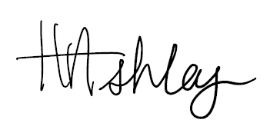
Heather R. Ashley
Executive Director, UF Alumni Association
Executive Director, Alumni Relations

