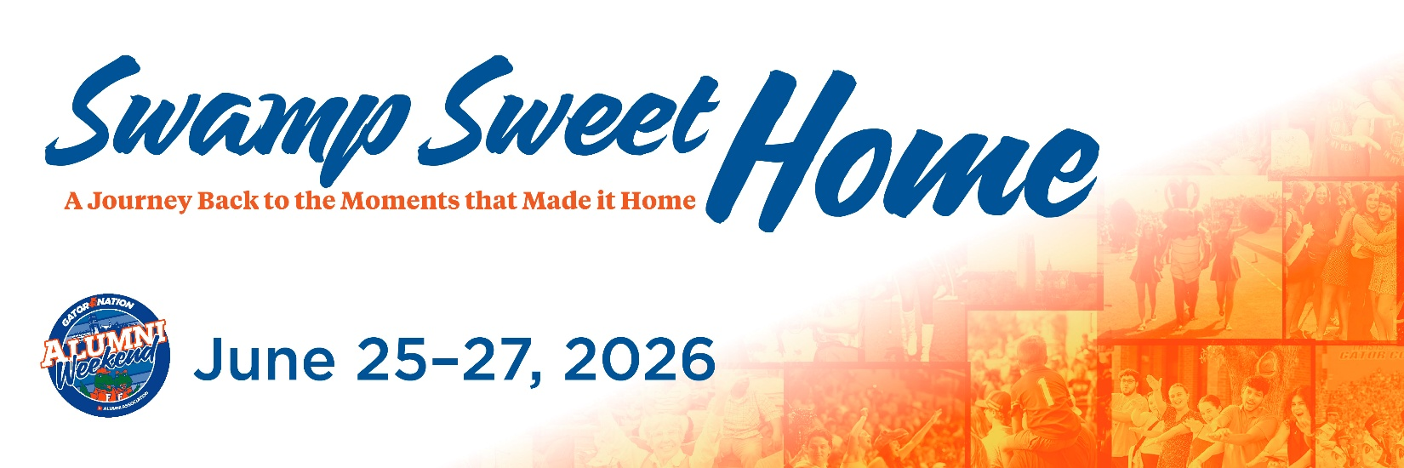

Milestone Classes Invite Email 1
Subject: Swamp Sweet Home: A Journey Back to the Moment that Made UF Home. You’re Invite to Alumni Weekend 2026
Dear [FIRST NAME],
No matter when you were here or how your experience looked, something meaningful happened for you at the University of Florida. A moment — big or small — helped shape who you are today.
This summer, we invite you back to reconnect with those moments during Alumni Weekend, a celebration designed to feel familiar, joyful and personal. We call it “Swamp Sweet Home” — a journey back to the moments that made UF feel like home.
Throughout the weekend, alumni from every generation and every Gator path will come together to celebrate shared memories and forge new ones. This cross-generational celebration offers a unique opportunity to connect with our storied traditions and Gators from many eras.
You will have the chance to connect with the Gator Nation as we honor special milestones, including:
- The Grand Guard induction of the class of 1976 for their 50th reunion
- The 40 Gators Under 40 celebration for the class of 2026, recognizing alumni whose leadership and impact are shaping the world today.
We also invite you to explore the full schedule and experience firsthand how much UF has grown – and how many new meaningful moments it is creating for today’s students. Alumni Weekend isn’t about reliving the past — it’s about celebrating how far you’ve come and the continued progress that defines our university.
[Button: Register for Alumni Weekend 2026 {use this link: https://cvent.me/e0qkRb }]
Early Bird registration is now open, giving you the opportunity to secure your spot for the full weekend or individual events at our best available rate. Whether you return for one afternoon or the entire journey, we would be thrilled to welcome you back home.
Warmest Regards and Go Gators!

Heather R. Ashley
Executive Director, UF Alumni Association
Executive Director, Alumni Relations

