Email 2 – Countdown to Commencement (Toast Save the date)

Drop Date: 4/15/2026
Subject Line: Cheers, Gators!
Preview Text: Celebrate Your UF Journey
Sender Display Name: University of Florida Alumni Association
Signer: Sarah Forron

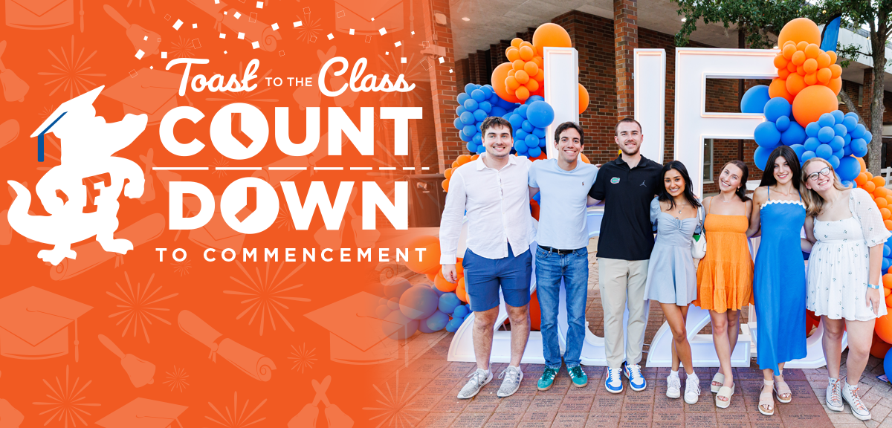

Good morning [Student Name],

Your UF journey has led to this momentous milestone – the Countdown to Commencement is still on!.

With Commencement right around the corner, we’re excited to celebrate the Class of 2026 at this year’s Toast to the Class! This signature event honors everything you have accomplished, gives you a moment to reflect on your time at UF and officially welcomes you into the Gator alumnihood.

Join us for a spirited “Cheers and Go Gators!” as we celebrate with fellow classmates, enjoy meaningful connections and kick off your next chapter with true Gator pride. You have earned this moment – don’t miss it!
Emerson Alumni Hall
Wednesday, April 29
6:30pm – 8pm

Leave Your Mark at UF
Brick Program Photo – Link to https://connect.ufalumni.ufl.edu/make-an-impact/commemorative-brick-pavers

Celebrate your time at UF in a lasting way. Whether commemorating your graduation, honoring a meaningful friendship, or recognizing those who supported you along the way, a personalized brick lets you Gator story live on – while supporting future students and alumni initiatives.

Stay Connected Wherever Life Takes You
Gator Club & Affiliate Group Photo – Link to https://connect.ufalumni.ufl.edu/events/calendar

Leaving the Swamp doesn’t mean leaving the Gator Nation®, it’s just the beginning. With 78 Gator Clubs (https://connect.ufalumni.ufl.edu/network/gatorclubs) & 10 Affiliate Groups (https://connect.ufalumni.ufl.edu/network/affiliategroups) worldwide, you will always have a place to cheer, connect and stay connected to the Orange & Blue.

Take Your Next Step as a Gator
Membership Photo – Link to https://www.ufalumni.ufl.edu/join/default.aspx?ac=MZAEZAS7

Enjoy exclusive benefits, one-of-a-kind experiences, member-only discounts and lifelong connection to the Gator Nation. This limited-time discounted Life Member rate is only available before graduation – don’t miss your chance. (https://www.ufalumni.ufl.edu/join/students/default.aspx?ac=MZAEZAS8),

We cannot wait to celebrate you, your accomplishments and officially welcome you into the Gator alumni community. Join us for the toast and start your next chapter as a proud UF alum.

