**Sumter County**

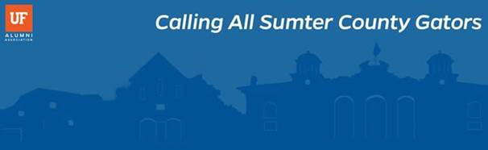

Greetings Gator Alumni, Friends, and Fans!

Members of your community have contacted the University of Florida Alumni Association to establish a Gator Club®, an official presence for the Gator Nation, in Sumter County. We are determining the level of interest to begin planning an organizational meeting in your area.

The University of Florida currently has over 92 alumni clubs across the country. Through comprehensive programming and engagement opportunities, a Gator Club® becomes a dynamic vehicle to support the University in the state and nation

If you are interested in working with us through the Club development process, please click [here](https://scott88.typeform.com/to/VkwKK9) to complete a brief survey.

Just want to know more about the Alumni Association and Gator Clubs®? No problem. Check out the Gator Club® and Affiliate Group [website](https://connect.ufalumni.ufl.edu/network/gatorclubs), or feel free to contact us with questions at [sfrancis@ufalumni.ufl.edu](mailto:sfrancis@ufalumni.ufl.edu).

Thank you for your interest, and we look forward to growing the Gator Nation.

Go Gators!