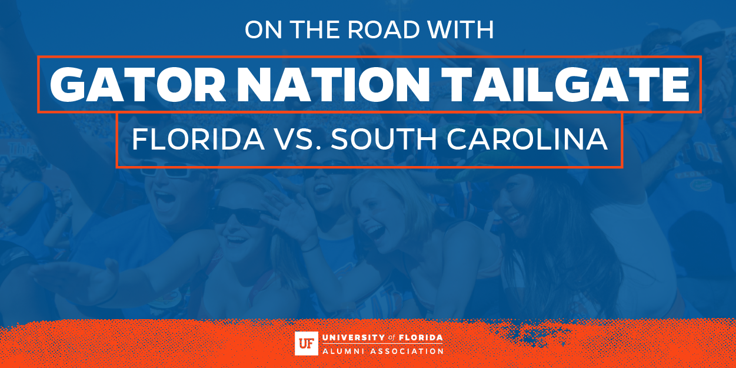
Dear <<INSERT FIRST NAME>>,
Join the UF Alumni Association and the Columbia Gator Club® for a tailgate at Seawell’s, located across from Willliams-Brice Stadium, prior to the Florida vs. South Carolina Football game on Saturday, November 11, 2017.
Admission is free for all Gators and the tailgate will begin 3 hours prior to kickoff. Purchase your food tickets now for $12 for UFAA Members and $15 for non-members. A limited number of food tickets will be available at the door. A cash bar will also be available.
Experience the tradition of Gator Nation Tailgates with festivities including:
UF Pep Band • Cheerleaders • Albert & Alberta • BEAT Stickers
Purchase Meal Tickets Today!
Additional Weekend Activities:
The Columbia Gator Club® is also hosting a Gator Nation Headquarters on Friday, November 10, 2017. Visit the Gator Club's® website for more details.
Go Gators!

